Indian Premier League

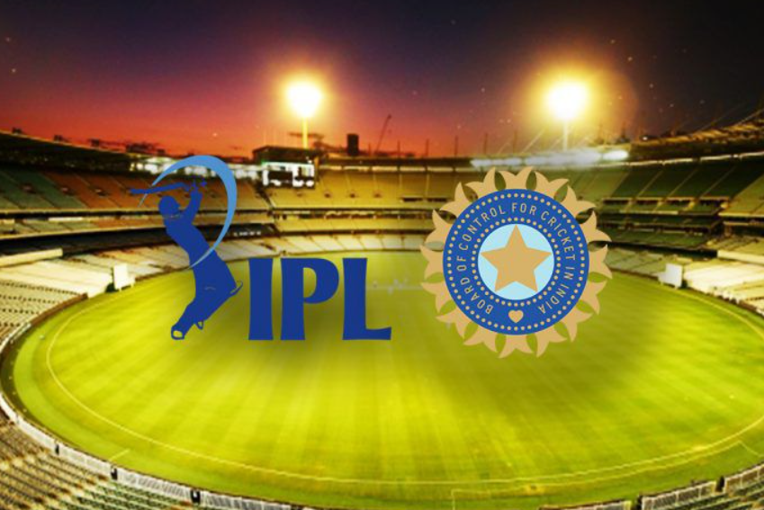

The Indian Premier League is a professional Twenty20 cricket league, contested by ten teams based out of ten Indian cities. The league was founded by the Board of Control for Cricket in India in 2007. It is usually held between March and May of every year and has an exclusive window in the ICC Future Tours Programme

**Stats and dashboards of Matches on the datasets from 2008-2020**

1. [What was the count of matches played in each season?](https://www.kaggle.com/saiswaroop018/ipl-data-analysis-and-visualization-project#1)

|  |  |
| --- | --- |
| **Season** | **Count of Matches Played in each season** |
| 2008 | 58 |
| 2009 | 57 |
| 2010 | 60 |
| 2011 | 73 |
| 2012 | 74 |
| 2013 | 76 |
| 2014 | 60 |
| 2015 | 59 |
| 2016 | 60 |
| 2017 | 59 |
| 2018 | 60 |
| 2019 | 60 |
| 2020 | 60 |
| **Grand Total** | **816** |

1. [How many runs were scored in each season?](https://www.kaggle.com/saiswaroop018/ipl-data-analysis-and-visualization-project#2)

|  |  |
| --- | --- |
| **Seasons** | **Sum of total_runs scored in each season** |
| 2008 | 914 |
| 2009 | 996 |
| 2010 | 834 |
| 2011 | 873 |
| 2012 | 1074 |
| 2013 | 786 |
| 2014 | 997 |
| 2015 | 1003 |
| 2016 | 949 |
| 2017 | 1153 |
| 2018 | 1548 |
| 2019 | 1267 |
| 2020 | 1087 |
| **Grand Total** | **13481** |

1. [What were the runs scored per match in different seasons?](https://www.kaggle.com/saiswaroop018/ipl-data-analysis-and-visualization-project#3)
2. [Who has umpired the most?](https://www.kaggle.com/saiswaroop018/ipl-data-analysis-and-visualization-project#4) Umpire **HDPK Dharmasena has umpired 43 matches**

|  |  |
| --- | --- |
| **Umpire Name** | **Matched Umpired** |
| **HDPK Dharmasena** | **43** |
| **Asad Rauf** | **35** |
| **AK Chaudhary** | **32** |
| **M Erasmus** | **30** |
| **Aleem Dar** | **29** |
| **Grand Total** | **169** |

1. [Which team has won the most tosses?](https://www.kaggle.com/saiswaroop018/ipl-data-analysis-and-visualization-project#5) Mumbai Indian has won most of the Tosses

|  |  |
| --- | --- |
| **Teams** | **Count of toss_winner** |
| Mumbai Indians | 106 |
| Kolkata Knight Riders | 98 |
| Chennai Super Kings | 97 |
| Rajasthan Royals | 87 |
| Royal Challengers Bangalore | 87 |
| Kings XI Punjab | 85 |
| Delhi Daredevils | 80 |
| Sunrisers Hyderabad | 57 |
| Deccan Chargers | 43 |
| Delhi Capitals | 20 |
| Pune Warriors | 20 |
| Gujarat Lions | 15 |
| Kochi Tuskers Kerala | 8 |
| Rising Pune Supergiants | 7 |
| Rising Pune Supergiant | 6 |
| **Grand Total** | **816** |

1. [What does the team decide after winning the toss?](https://www.kaggle.com/saiswaroop018/ipl-data-analysis-and-visualization-project#6) Team decide to Field

|  |  |
| --- | --- |
| **Teams** | **Count of toss_decision** |
| bat | 39.22% |
| field | 60.78% |
| **Grand Total** | **100.00%** |

1. [How toss decision varies across seasons?](https://www.kaggle.com/saiswaroop018/ipl-data-analysis-and-visualization-project#7)

|  |  |  |  |
| --- | --- | --- | --- |
| **Count of toss_decision** | **Column Labels** |  |  |
| **Seasons** | **bat** | **field** | **Grand Total** |
| 2008 | 26 | 32 | 58 |
| 2009 | 35 | 22 | 57 |
| 2010 | 39 | 21 | 60 |
| 2011 | 25 | 48 | 73 |
| 2012 | 37 | 37 | 74 |
| 2013 | 45 | 31 | 76 |
| 2014 | 19 | 41 | 60 |
| 2015 | 25 | 34 | 59 |
| 2016 | 11 | 49 | 60 |
| 2017 | 11 | 48 | 59 |
| 2018 | 10 | 50 | 60 |
| 2019 | 10 | 50 | 60 |
| 2020 | 27 | 33 | 60 |
| **Grand Total** | **320** | **496** | **816** |

1. [Does winning the toss implies winning the game?](https://www.kaggle.com/saiswaroop018/ipl-data-analysis-and-visualization-project#8)

NO

1. [How many times chasing team has won the match?](https://www.kaggle.com/saiswaroop018/ipl-data-analysis-and-visualization-project#9)

435 times

|  |  |  |
| --- | --- | --- |
| **Team 2** | **Won the Match** | **Total Matches** |
|  | 435 | 816 |

1. [Which all teams had won this tournament?](https://www.kaggle.com/saiswaroop018/ipl-data-analysis-and-visualization-project#10) Mumbai Indians

|  |  |
| --- | --- |
| **Teams** | **Count of Tournament** |
| Mumbai Indians | 120 |
| Chennai Super Kings | 106 |
| Kolkata Knight Riders | 99 |
| Royal Challengers Bangalore | 91 |
| Kings XI Punjab | 88 |
| **Grand Total** | **504** |

1. [Which team has played the most number of matches?](https://www.kaggle.com/saiswaroop018/ipl-data-analysis-and-visualization-project#11)

Mumbai Indian Played Most of the matches which is 200

|  |  |  |  |
| --- | --- | --- | --- |
| **Teams** | **Count of team1** | **Count of team2** | **Total Matches Played** |
| **Mumbai Indians** | **97** | **106** | **200** |

1. [Which team has won the most number of times?](https://www.kaggle.com/saiswaroop018/ipl-data-analysis-and-visualization-project#12)

Mumbai Indian 106 times

1. [Which team has the highest winning percentage?](https://www.kaggle.com/saiswaroop018/ipl-data-analysis-and-visualization-project#13)

Mumbai Indians has the Highest winning 23 %

|  |  |
| --- | --- |
| **Teams** | **Count of winner** |
| Mumbai Indians | 23.81% |
| Chennai Super Kings | 21.03% |
| Kolkata Knight Riders | 19.64% |
| Royal Challengers Bangalore | 18.06% |
| Kings XI Punjab | 17.46% |
| **Grand Total** | **100.00%** |

1. [Is there any lucky venue for a particular team?](https://www.kaggle.com/saiswaroop018/ipl-data-analysis-and-visualization-project#14) Eden Gardens

|  |  |
| --- | --- |
| **Row Labels** | **Count of winner** |
| Eden Gardens | 77 |
| Feroz Shah Kotla | 74 |
| M Chinnaswamy Stadium | 65 |
| Rajiv Gandhi International Stadium, Uppal | 64 |
| Wankhede Stadium | 73 |
| **Grand Total** | **353** |

1. [Comparison between two teams](https://www.kaggle.com/saiswaroop018/ipl-data-analysis-and-visualization-project#15)

|  |  |  |  |
| --- | --- | --- | --- |
|  |  |  |  |
| **Count of winner** | **Column Labels** |  |  |
| **Teams** | **Mumbai Indians** | **Royal Challengers Bangalore** | **Grand Total** |
| 2008 | 7 | 7 | 14 |
| 2009 | 1 | 16 | 17 |
| 2010 | 7 | 9 | 16 |
| 2011 | 8 | 8 | 16 |
| 2012 | 8 | 7 | 15 |
| 2013 | 9 | 8 | 17 |
| 2014 | 7 | 7 | 14 |
| 2015 | 8 | 8 | 16 |
| 2016 | 7 | 8 | 15 |
| 2017 | 10 | 6 | 16 |
| 2018 | 7 | 7 | 14 |
| 2019 | 9 | 7 | 16 |
| 2020 | 9 | 10 | 19 |
| **Grand Total** | **97** | **108** | **205** |

1. [Particular Batsmen analysis](https://www.kaggle.com/saiswaroop018/ipl-data-analysis-and-visualization-project#16)

|  |  |  |
| --- | --- | --- |
| **Sum of total_runs** | **Column Labels** |  |
| **Row Labels** | **V Kohli** | **Grand Total** |
| 2008 | 187 | 187 |
| 2009 | 258 | 258 |
| 2010 | 320 | 320 |
| 2011 | 584 | 584 |
| 2012 | 375 | 375 |
| 2013 | 655 | 655 |
| 2014 | 373 | 373 |
| 2015 | 519 | 519 |
| 2016 | 998 | 998 |
| 2017 | 314 | 314 |
| 2018 | 539 | 539 |
| 2019 | 472 | 472 |
| 2020 | 487 | 487 |
| (blank) |  |  |
| **Grand Total** | **6081** | **6081** |

1. [Innings wise comparison between teams](https://www.kaggle.com/saiswaroop018/ipl-data-analysis-and-visualization-project#17)

|  |  |  |  |
| --- | --- | --- | --- |
|  |  |  |  |
|  | **Kolkata Knight Riders** | **Royal Challengers Bangalore** | **Grand Total** |
| **Inning** |  |  |  |
| 1 | 222 | 222 | 222 |
| 2 | 82 | 82 | 82 |
| **Grand Total** | **304** | **304** | **304** |

1. [Which team has scored the most number of 200+ scores?](https://www.kaggle.com/saiswaroop018/ipl-data-analysis-and-visualization-project#18)

Kochi Tuskers Kerala

1. [Which team has conceded 200+ scores the most?](https://www.kaggle.com/saiswaroop018/ipl-data-analysis-and-visualization-project#19)
2. Kochi Tuskers Kerala
3. [What was the highest run scored by a team in a single match?](https://www.kaggle.com/saiswaroop018/ipl-data-analysis-and-visualization-project#20) 246 Runs

|  |  |  |  |  |
| --- | --- | --- | --- | --- |
| **Sum of total_runs** | **Column Labels** |  |  |  |
| **Match id** | **1** | **2** | **(blank)** | **Grand Total** |
| 419137 | 246 | 223 |  | 469 |
| 1136604 | 245 | 214 |  | 459 |
| **Grand Total** | **491** | **437** |  | **928** |

1. [Which is the biggest win in terms of run margin?](https://www.kaggle.com/saiswaroop018/ipl-data-analysis-and-visualization-project#21) 146 by Team Mumbai Indians

|  |  |
| --- | --- |
| **Row Labels** | **Max of result_margin** |
| Mumbai Indians | 146 |
| Royal Challengers Bangalore | 144 |
| Kolkata Knight Riders | 140 |
| Sunrisers Hyderabad | 118 |
| Kings XI Punjab | 111 |
| **Grand Total** | **146** |

1. [Which batsmen have played the most number of balls?](https://www.kaggle.com/saiswaroop018/ipl-data-analysis-and-visualization-project#22)

Virat Kohli

1. [Who are the leading run-scorers of all time?](https://www.kaggle.com/saiswaroop018/ipl-data-analysis-and-visualization-project#23)
2. Virat Kohli
3. [Who has hit the most number of 4's?](https://www.kaggle.com/saiswaroop018/ipl-data-analysis-and-visualization-project#24) Virat Kohli
4. [Who has hit the most number of 6's?](https://www.kaggle.com/saiswaroop018/ipl-data-analysis-and-visualization-project#25) C H Gayle
5. [Who has the highest strike rate?](https://www.kaggle.com/saiswaroop018/ipl-data-analysis-and-visualization-project#26)
6. [Who is the leading wicket-taker?](https://www.kaggle.com/saiswaroop018/ipl-data-analysis-and-visualization-project#27) Ds Kulkari
7. [Which stadium has hosted the most number of matches?](https://www.kaggle.com/saiswaroop018/ipl-data-analysis-and-visualization-project#28)

Edan Gardens

|  |  |
| --- | --- |
| **Row Labels** | **Count of venue** |
| Eden Gardens | 77 |
| Feroz Shah Kotla | 74 |
| Wankhede Stadium | 73 |
| **Grand Total** | **224** |

1. [Who has won the most MOM awards?](https://www.kaggle.com/saiswaroop018/ipl-data-analysis-and-visualization-project#29) AB de Villiers

|  |  |
| --- | --- |
| **Row Labels** | **Count of player_of_match** |
| AB de Villiers | 23 |
| CH Gayle | 22 |
| DA Warner | 17 |
| MS Dhoni | 17 |
| RG Sharma | 18 |
| **Grand Total** | **97** |

1. [What is the count of fours hit in each season?](https://www.kaggle.com/saiswaroop018/ipl-data-analysis-and-visualization-project#30) 277
2. [What is the count of sixes hit in each season?](https://www.kaggle.com/saiswaroop018/ipl-data-analysis-and-visualization-project#31)
3. [What is the count of runs scored from boundaries in each season?](https://www.kaggle.com/saiswaroop018/ipl-data-analysis-and-visualization-project#32)
4. [What is the run contribution from boundaries in each season?](https://www.kaggle.com/saiswaroop018/ipl-data-analysis-and-visualization-project#33)
5. [Which team has scored the most runs in the first 6 overs?](https://www.kaggle.com/saiswaroop018/ipl-data-analysis-and-visualization-project#34)
6. [Which team has scored the most runs in the last 4 overs?](https://www.kaggle.com/saiswaroop018/ipl-data-analysis-and-visualization-project#35)
7. [Which team has the best scoring run-rate in the first 6 overs?](https://www.kaggle.com/saiswaroop018/ipl-data-analysis-and-visualization-project#36)
8. [Which team has the best scoring run-rate in the last 4 overs?](https://www.kaggle.com/saiswaroop018/ipl-data-analysis-and-visualization-project#37)

Kolkata Knight riders

**Conclusion**

**Mumbai Indians Has played most of the Matches**

**Mumbai Indians has Won most of the Matches**

**Venue Eden Gardens hosted of the Matches were Played & was the luckiest ground for most of the teams.**

**AB de Villiers was Awarded as Most Of the Match**

**Virat Kohli is the Leading Runs Scorer across the season**